FULL STACK
EXPERIMENT-2.2

AIM:
To design and implement a dynamic product filtering system using JavaScript DOM Manipulation, where products can be filtered based on category, price, rating, and search text with dropdowns and input fields.

THEORY:
- DOM Manipulation – JavaScript allows selecting, creating, and updating HTML elements dynamically using methods like querySelector, appendChild, and innerHTML.
- Events – Filters trigger events (change, input, click), which update the product list in real time.
- Filtering Logic – An array of product objects is iterated, applying conditions based on selected filters.
- Sorting – Products can be sorted (by price, rating, or name) using array sorting methods.
- Output Rendering – Matching products are displayed as cards. If no product matches, an empty state message is shown.
This simulates a real-world e-commerce filter system like Amazon, Flipkart, etc.

PROCEDURE:
- Create Dataset – Define an array of products with properties (id, name, category, price, rating, tags).
- UI Design – Add dropdowns for category, price, rating, and input for search.
- Event Binding – Attach listeners to dropdowns and input fields.
- Filtering Function – Apply multiple conditions on the product array.
- DOM Update – Render filtered products as cards in a grid.
- Reset Function – Restore all products when filters are cleared.

CODE:
<!doctype html>
<html lang="en">
<head>
<meta charset="utf-8" />
<meta name="viewport" content="width=device-width, initial-scale=1" />
<title>Dynamic Product Filter</title>
<style>
body{font-family:Arial,sans-serif;background:#f6f8fa;margin:0;padding:20px;}
h2{text-align:center}
.toolbar{margin-bottom:20px;display:flex;gap:10px;flex-wrap:wrap}
select,input{padding:8px;border-radius:6px;border:1px solid #ccc}
button{padding:8px 14px;border:none;border-radius:6px;background:#007bff;color:white;cursor:pointer}
.cards{display:grid;grid-template-columns:repeat(auto-fill,minmax(200px,1fr));gap:14px}
.card{border:1px solid #ccc;border-radius:10px;padding:12px;background:white}
.title{font-weight:bold}
.price{color:green}
.empty{text-align:center;color:#888;margin-top:20px}
</style>
</head>
<body>
<h2>Dynamic Product Filter</h2>

<!-- Filter Controls -->
<div class="toolbar">
<select id="category">
<option value="all">All Categories</option>
<option>Electronics</option>
<option>Clothing</option>
<option>Home</option>
<option>Books</option>
</select>

<select id="price">
<option value="all">All Prices</option>
<option value="0-1000">₹0–₹1000</option>
<option value="1000-5000">₹1000–₹5000</option>
<option value="5000-20000">₹5000–₹20000</option>
</select>

<select id="rating">
<option value="0">Any Rating</option>
<option value="3">3★ & above</option>
<option value="4">4★ & above</option>
</select>

<input type="text" id="search" placeholder="Search product...">
<button id="reset">Reset</button>
</div>

<!-- Products Display -->
<div class="cards" id="cards"></div>
<div class="empty" id="empty" style="display:none">No products found!</div>

<script>
const products = [
{id:1,name:"Wireless Earbuds",category:"Electronics",price:2499,rating:4.3},
{id:2,name:"Smart TV 43\"",category:"Electronics",price:22999,rating:4.6},
{id:3,name:"Cotton T-Shirt",category:"Clothing",price:799,rating:4.1},
{id:4,name:"Running Shoes",category:"Clothing",price:3999,rating:4.7},
{id:5,name:"Steel Kettle",category:"Home",price:1299,rating:4.2},
{id:6,name:"Foam Pillow",category:"Home",price:1599,rating:4.4},
{id:7,name:"The Pragmatic Programmer",category:"Books",price:999,rating:4.8},
{id:8,name:"Data Structures in JS",category:"Books",price:649,rating:4.5}
];

const UI = {
category: document.querySelector('#category'),
price: document.querySelector('#price'),
rating: document.querySelector('#rating'),
search: document.querySelector('#search'),
reset: document.querySelector('#reset'),
cards: document.querySelector('#cards'),
empty: document.querySelector('#empty')
};

// Render Function
function render(list){
UI.cards.innerHTML = "";
if(list.length === 0){
UI.empty.style.display = "block";
return;
}
UI.empty.style.display = "none";
list.forEach(p=>{
const card = document.createElement('div');
card.className = 'card';
card.innerHTML = `<div class='title'>${p.name}</div>
<div>${p.category}</div>
<div class='price'>₹${p.price}</div>
<div>⭐ ${p.rating}</div>`;
UI.cards.appendChild(card);
});
}

// Filter Function
function filterProducts(){
let list = products.filter(p=>{
let cat = UI.category.value==="all" || p.category===UI.category.value;
let pr = true;
if(UI.price.value!=="all"){
const [min,max] = UI.price.value.split('-').map(Number);
pr = p.price>=min && p.price<=max;
}
let rt = p.rating >= Number(UI.rating.value);
let sr = p.name.toLowerCase().includes(UI.search.value.toLowerCase());
return cat && pr && rt && sr;
});
render(list);
}

// Event Listeners
[UI.category,UI.price,UI.rating,UI.search].forEach(el=>{
el.addEventListener('input',filterProducts);
});
UI.reset.addEventListener('click',()=>{
UI.category.value='all';UI.price.value='all';UI.rating.value='0';UI.search.value='';
render(products);
});

// Initial render
render(products);
</script>
</body>
</html>

OUTPUT:
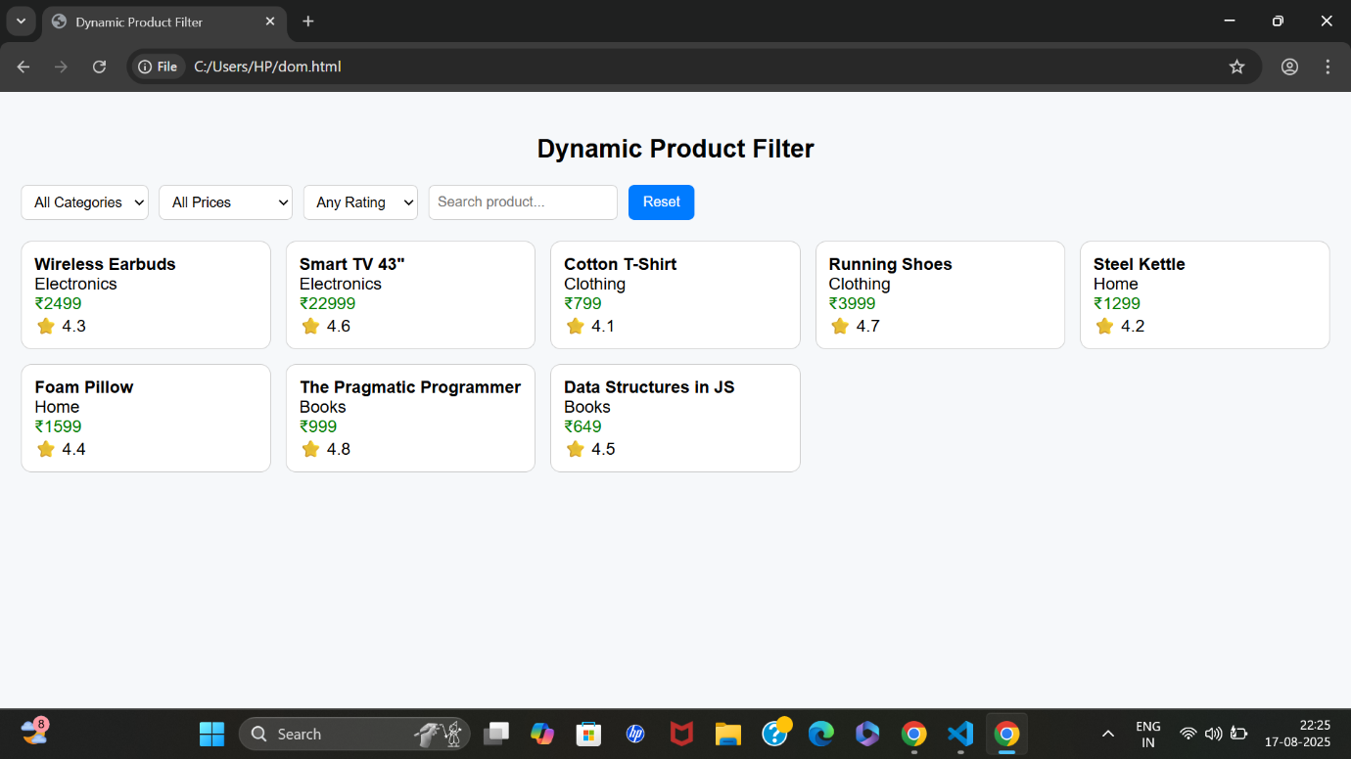
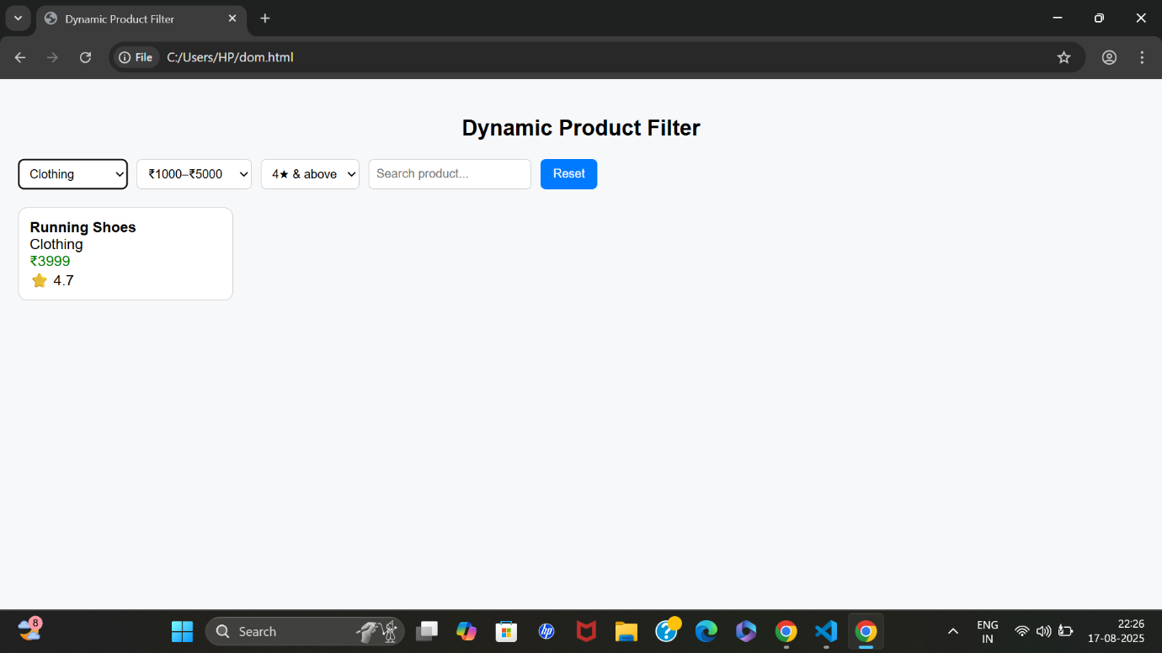
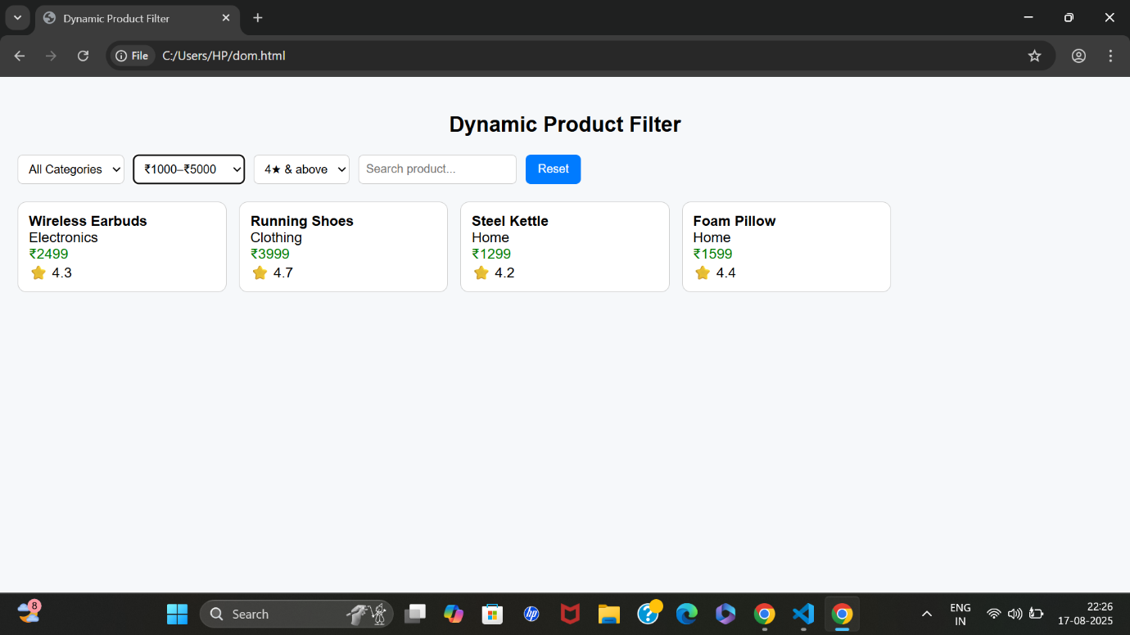

LEARNING OUTCOME:
- At first, all products are displayed as cards.
- Selecting category = Electronics shows only electronics.
- Filtering by price = 0–1000 narrows results further.
- Searching "js" shows the Data Structures in JS book.
- If no product matches → "No products found!" message appears.

